Oleksandr Yardas
Bio 150-03
10/23/16
Hyla Two way ANOVA problem set
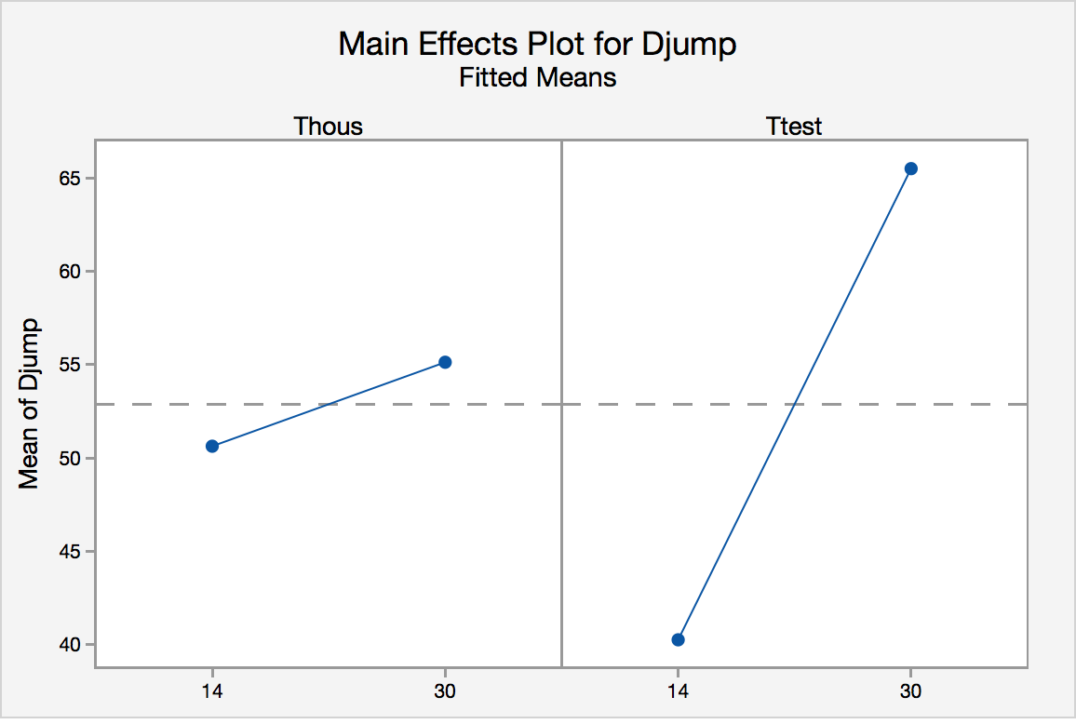
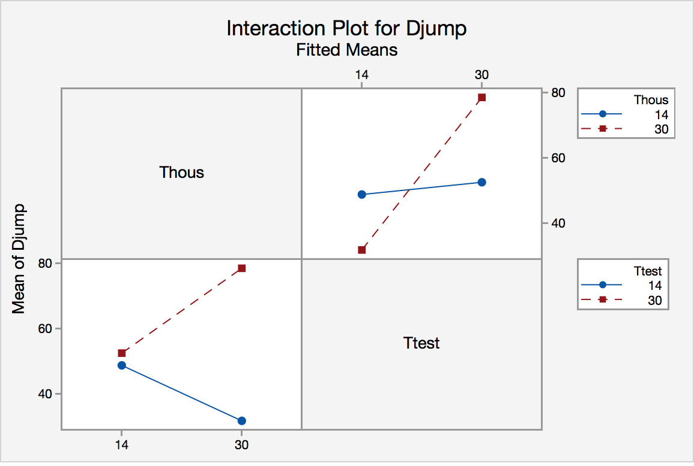
1) In the above case, are there significant effects of test temperature? Of housing temperature? What are the forms of these effects?

There are significant effects of test temperature (F=88.58, p<0.0001) but the effects of housing temperature were not significant (F=2.81, p=0.1193). Both variables were observed having the trend of increasing jump distance when the temperature was increased

2) Is there a significant effect of the interaction between test temperature and housing temperature? If so, what is its form and what is its biological meaning?

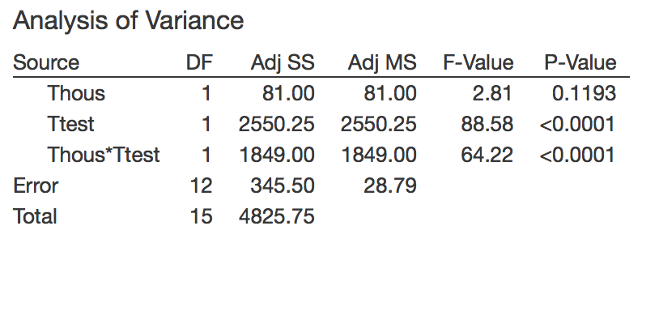
Frogs housed in 14C had a higher mean jumping distance when tested in 30C. Frogs housed in 30C had a higher mean jumping distance when tested in 30 C. Frogs tested in 14C had a higher mean jumping distance when housed in 14C. Frogs who were tested in 30C had a higher mean jumping distance when tested in 30C. None of the lines were parallel, which means that the results are statistically significant. The results imply that the mean jumping distance of frogs decreased when frogs are housed at a reasonable survivable temperature, and are tested at a lower temperature. Mean jumping distance does not change or increases when frogs are tested in a temperature that is the same or higher than the temperature that they are housed in.

